- 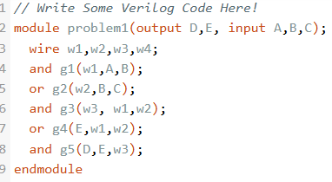

- a. One would be able to daisy chain outputs of full adders, Cout would be into Cins of subsequent combinational circuits.

b. 

 